Company & Industry Context
Company Description
Best Buy is the world’s largest consumer electronics retailer. It offers:
- Computing & Mobile Phones: desktops, laptops, phones, & wearables
- Consumer Electronics: digital imaging, health & fitness, home theatre (soundbars, TVs etc.), portable audio, & smart home
- Appliances: Complete range of household appliances
- Entertainment: drones, gaming, VR, toys and software
- Services: high-margin in-house delivery, installations, set-up, repair, membership, & health-related services
- Others: Baby care & items, food processors & outdoor living

At a market cap of $15.6 billion, the company generated $41.5 billion in revenue, $2.6 billion in EBITDA, and $1.4 billion in free cash flow in FY’25, operating on razor-thin 4% operating margins. The company has had no revenue growth in the past 10 years, reflecting the declining share of electronics sales in the retail channel and a maturing overall market. The company pays $800 million a year in dividends and has planned $600 million in stock buybacks in FY ’26. Over the past 6 years, it has returned almost all its free cash flow to shareholders through both dividends and buybacks.

The company also has private label brands, such as Insignia (TVs & appliances), Best Buy Essentials (entry-level tech), Rocketfish (cables, mounts, surge, connectivity), and others in health & outdoor living (see Appendix A).
Best Buy primarily functions as a merchandiser, purchasing products in bulk from OEMs and retailing them through its integrated in-store and online channels, offering direct-to-consumer sales, in-store pickup and ship-from-store fulfillment [BBY 10-K 2024]. While the company does not disclose the GMV share of this model, it also implements a Supplier Direct Fulfilment program (SDF, i.e. vendor drop-shipping) to facilitate a meaningful portion of its orders. It operates over 1,000 stores across the U.S. and Canada, encompassing more than 37 million square feet of retail space, and offers a broad assortment of consumer electronics, home appliances and entertainment products, complemented by services that support the full technology lifecycle (see Appendix C for a description of the company’s historical evolution).
BBY’s discount to its peers increased sizeably this year to reflect the disproportionate impact of both a near-term macro downturn and tariff-demand elasticity on its cyclical, price-sensitive revenue. At 6.9x EV / EBITDA, it currently trades at a 55% discount to the average of its five closest competitors—AMZN, EBAY, WMT, TGT, and COST, compared to an average of between 47% and just under 50% over the past three years.
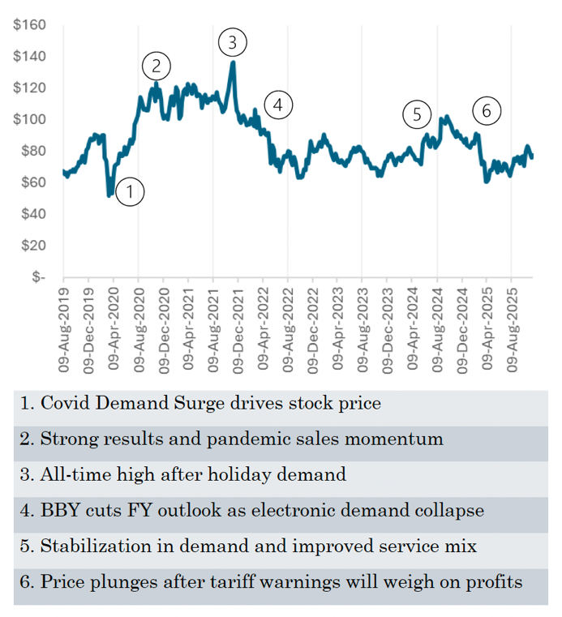
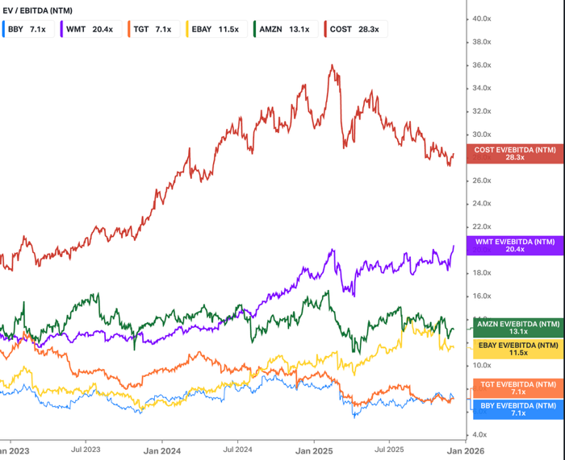

Market Overview
Best Buy has built a defensible moat in retail tech sales (still the largest sales channel for consumer electronics) because it is effectively the only retailer that sits at the intersection of four things: scale pure-play electronics, multi-vendor OEM showrooms, a dense omnichannel store network, and a national services/installation arm.
The company dominates offline tech sales, which account for 2/3rds of its $41 billion in sales in FY ’25, and 33% of the retail consumer electronics market overall. This affords it category-specific bargaining power—allowing it to aggressively price-match in-store products with e-commerce platforms to avoid “showrooming” (see Appendix C) and gain exclusive SKUs—and assortment depth that generalists like Walmart, Target or Costco can’t match in tech.
The high capital barriers, the industry’s abysmal margins and the breadth of services and installation capability that BBY offers through Geek Squad—a 20,000 person service workforce—renders the company’s business model & scale extremely difficult to replicate for consumer electronics. Moreover, the direct competitors the company had during the 1990s and 2000s—both broad (e.g. Circuit City, RadioShack) and category-focused (e.g. CompUSA)—were eliminated post-GFC, and the domination of commodified tech sales by e-commerce and big box generalists like Walmart and Target (see Appendix C for further discussion). There is not, nor is there room for, a second, scaled consumer electronics brick-and-mortar retailer.

Despite a roughly 2-3% annual market share erosion in recent years, retail still dominates the majority of tech sales (over 60%) as many customers still rely on expert advice and inspecting products in-person when they are uncertain about what to purchase. E-commerce’s strongest use case—enabling customers to search for specific products or SKUs—is weakened when shoppers lack sufficient product knowledge and awareness.
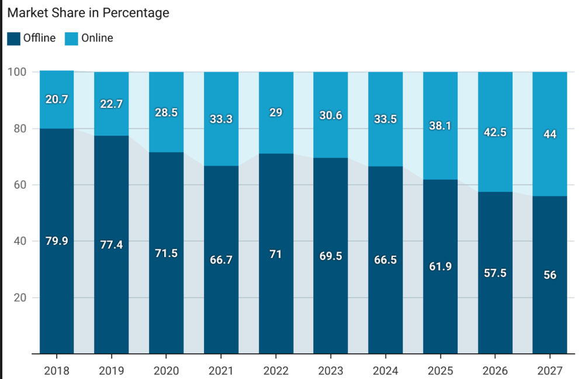
To drive higher transactions and better mix than traditional store layouts, the company incorporates large demo areas in its stores dedicated to specific OEMs, who fund the fixtures, staffing, and immersive branded experiences at no incremental cost to BBY, to raise conversion and up- and cross-sell. It hosts more than 1,400 Samsung Experience Shops, along with Windows/Microsoft stores and longstanding Apple shop-in-shops. The “shop-in-shop” concept also allows OEMs to expand their retail footprint at minimal cost. BBY fends off competition from their own retail channels by featuring a very broad assortment of brands that can be compared side-by-side and/or purchased complimentarily for more intricate setups (e.g. gaming & home theatre).
However, it fails to dominate in e-commerce—historically a second channel for the company to drive in-store foot-traffic—holding just 7% of the market for online consumer electronics sales (see Appendix B for calculation methodology). While it can compete with Prime shipping by leveraging its over 1,000 big-box stores double as local fulfillment nodes for click-and-collect, same-day pickup, and ship-from-store, with in-person help—an omnichannel loop that pure e-commerce players lack—it can’t defeat Amazon’s dominance in search habit, marketplace breadth, Prime ecosystem, and purpose-built fulfillment infrastructure. In addition to Amazon, it also faces competition from other consumer electronics e-commerce sites (i.e. marketplaces for 3rd party vendors—NOT merchandisers) that undercut it in costs for commodified tech items by supplementing cheaper brands & SKUs that BBY does not carry, such as NewEgg, EBay, B&H, and players for more niche, rarer items like Micro Center.
Supply-Side Business Drivers: Logistical Operations & Vendor Relations
BBY’s supply chain (a traditional hub-and-spoke model) competes effectively with Prime on shipping speed & accuracy, while strategically & optimally minimizing costs, but has high Asian & OEM concentration. The company also maintains low working capital needs due to its robust bargaining power with suppliers.
BBY’s supply chain boasts the same fulfilment efficiency as that of Amazon while requiring marginal capex to be maintained & expanded for three key reasons:
- It receives high vendor support—vendors fulfill a material portion of their own shipments as part of the Supplier Direct Fulfilment program, allowing BBY to expand product assortment without expanding distribution footprint
- It’s already in-place, largely as part of the recent overhaul under Renew Blue
- It leverages its stores as mini-fulfillment centers—while also leveraging distribution centers (less so in recent years with incremental efficiency investments), the geographic proximity of the firm’s massive store footprint to major American population centers is a substantial inherent advantage.
(See Appendix D for additional details on the company’s supply chain operations)
The company’s supply chain is concentrated in China (where, by the CEO’s statement, 30-35% of the company’s merchandise originates, down from 55% at the end of FQ4 ‘25), and in a select number of OEMs (the top 5 OEMs—Apple, Samsung, HP, Sony, and LG account for 55% of total merchandise, while the top 20 account for 80%). This exposes the company to geopolitical & systematic China-related risks, and, while the impact of supplier concentration on the company’s bargaining power is more than offset by the fortitude of its market position, it still leaves it exposed to idiosyncratic supply chain risks as well.
BBY’s working capital needs are low, again due to its robust bargaining power with its suppliers, as it boasts a cash conversion cycle of just 11 days, higher than those of WMT (4 days), TGT (2), and COST (2), but lower than ODP (25), GME (32), TJX (24), CVS (15), DG (33), DLTR (34), HD (47), and LOW (40).

Demand-Side Business Drivers: Cyclicality & Pricing Power
On the consumer-side, BBY is a heavily event-driven business vs traditional retail, driven by both seasonality (i.e. “drive times”—back-to-school, Black Friday, Christmas etc.), and tech product launch & upgrade cycles (e.g. Switch, Windows 10 EoL, AI PCs). Moreover, cyclicality drivers differ widely between business units—for instance, innovation cycles drive computing & gaming results. TVs are volatile, but BBY uses its traditional strategy of leaning on bigger-screen, higher ticket items to protect margin. Appliances (accounting for 11% of sales), however, are heavily driven by the housing market & are promotional.
The company has average pricing power, with gross margins on-par with or above retailers in adjacent or overlapping product categories, while blanketly price matching its shelf products with e-commerce sites by predominantly offering its OEMs’ higher-ticket items, and to a lesser extent, exclusive SKUs. BBY boasts a gross margin of roughly 23%, being middle-of-the-pack relative to peers such as ODP (B2B office electronics pureplay, with 20% GM), NewEgg (discount online retailer—11%), and GME (overlap with gaming—30%). On Amazon—the largest online marketplace for electronics—external consumer electronics merchandisers have gross margins ranging from 15 – 30% (indicated by 3rd party data), with the midpoint neatly equal to that of BBY.
Marketplace & Ads:
Best Buy has quietly been evolving from a pure-play specialty retailer into a tech-focused platform with two high-margin, asset-light growth engines: Marketplace (3P) and Best Buy Ads (retail media). After an early, underpowered US marketplace attempt a decade ago, the company spent years refining the model in Canada, proving it can vet sellers, expand assortment, and protect the customer experience without taking inventory risk. That playbook underpins the new US Marketplace, which launched in 2025 and immediately expanded online assortment several-fold, particularly in long-tail accessories and adjacent categories, while keeping returns, policies, and brand control inside the Best Buy umbrella.
Best Buy Ads sits on top of this ecosystem and monetizes BBY’s high-intent, higher-ticket traffic through sponsored product placements, offsite campaigns, and in-store media (TV walls, endcaps, takeovers). As Marketplace scales seller count and SKUs, it naturally feeds Best Buy Ads with more advertisers and ad inventory, creating a flywheel: more assortment raises customer relevance and traffic, leads to more ad spend, which in turn earns high-margin dollars to reinvest in price and experience. Together, Marketplace and Ads give Best Buy a credible path to structurally higher margins and profit-per-visit without relying solely on traditional big-box retail economics.
Thesis & Catalysts
- The Market is Underpricing Outsized Upside Potential for BBY from the AI PC Supercycle
  - While OEMs received a 15–20% premium from the AI PC theme in mid-2024, BBY did not—despite that it will capture a larger share of the upgrade wallet by earning not only PC margins, but also higher attach due to the inherently higher cross-/up-sell opportunities in its stores, incremental memberships, and retail media dollars
  - BBY is positioned to capture a disproportionate share of AI PC sales versus both e-commerce marketplaces and OEM’s direct channels, as consumers facing a steep education curve will increasingly seek human advice, live demos, and side-by-side comparisons across a broad, multi-brand assortment
    - Customers will need to be educated on new brands (e.g. “Copilot+”), hardware requirements (e.g. NPUs, SSDs), and software nuances (e.g. “on-device” vs cloud AI)
  - Only a marginal fraction of the extent of this uplift has already materialized in the company’s comps growth since new AI PC SKUs hit the market last year because adoption has been temporarily slower than expected, but is bound to materially accelerate within the next 12-24 months due to:
    - The penetration of AI workloads raising baseline compute power requirements still being highly nescient
    - The substantial base of machines purchased during the COVID pull forward of consumer electronics demand 4-5 years ago approaching obsolescence by ‘26/’27
    - Windows 10—the flagship OS of the past decade with an installed base of millions—end-of-support last month pushing for upgrades on 7-10 year old machines and enterprises seeking to future-proof their hardware with AI PCs (for comparison, Windows 7 EOS—which had a much smaller install-based—accelerated PC demand for 12 months post-EOS; the marginal uplift post Windows 8 EOS is inadequate for comparison as it had far worse both consumer & enterprise uptake than either 7 or 10)
- The Market is Underpricing the Upside to the Ad Business from Best Buy Marketplace
  - While the Street is adequately pricing the direct upside from Marketplace to revenues, margins & incremental share acquisition from an expanded product assortment at little cost to BBY, it is not pricing in the potential for outsized vendor ad budget share acquisition,
  - The value proposition for vendors is very substantial: they gain access to high-intent, higher-ASP customers at a lower CAC than on generalist (e.g. Amazon) or lower-ticket e-commerce platforms (e.g., NewEgg), while small vendors benefit from the credibility of the Best Buy brand
    - In contrast, the Street largely values Marketplace as if it’s only an incremental channel and a way to list more SKUs than BBY carries in-store and limited flywheel effects with the ad business
  - This audience is drawn to BestBuy.com’s immense value proposition. They trust BBY knowing that sellers are vetted and they have more recourse than any other e-commerce site (can bring products for questions & troubleshooting and facilitate returns in-store)
  - Range of sellers & SKUs, in addition to OI accretion and the ad flywheel, is expected to ramp through 2026
- A staggering while highly sustainable 7.3% yield from dividends & buybacks alone more than offsets declines from secular shifts from in-person to online and severely de-risks the opportunity
  - The company has been actively shutting down 1-3% of its stores annually for the past 6 years & focused on maximizing store productivity, while implementing acute discipline with capital expenditures
  - Nearly 2/3^{rds} of total capex goes to e-commerce & IT related investments, which will be substantially accretive to OI due to the high margins of Marketplace & ads as those platforms continue to ramp up
  - Capex related to the retail business—store upgrades & supply chain investments—collectively represents less than 15% of free cash flows, as vendors incur all of the cost for their in-store showrooms
  - The company has a healthy margin of safety to cover its dividends, at an FCF/dividend ratio of 1.7x
Risks & Mitigants
- High supply chain concentration in China amplifies tariff uncertainty
  - BBY only imports 2-3% of its own merchandise, mitigating the direct hit from tariffs, and
  - The market is overstating tariff-driven demand elasticity in PCs, as it will be dulled by a structural shift toward higher-baseline-performance machines for AI workloads, a large pandemic-era install base approaching obsolescence, and Windows 10 EOS plus enterprises upgrading to future-proof for AI.
- BofA believes that the commodification of consumer electronics will erode BBY’s advantage in advice & assortment
  - This view fails to capture the potential for Best Buy Marketplace to absorb a meaningful share of this shift, given its inherent value proposition and higher-quality audience.
  - It also underestimates Best Buy’s ability to gain share in commoditized, lower-ticket currently absent in its stores through Marketplace, where expanded assortment and BBY’s trust halo can redirect spend from generalist platforms.
- Weak TV and appliance sales due to lack of innovation & dulled housing starts respectively
  - Mitigated by multi-year mobile upgrade cycle that has driven carrier investment in BBY store mobile showrooms, in addition to
  - GTA VI release in 2026, further amplified by cross & upsells, and
  - Robust momentum in wearables & AR, where the company is uniquely positioned to capturing an outsized portion due to the need for live demos & expert guidance
- Macro downturn weighing considerably on discretionary consumer electronics spending, lowering comps while boosting promotional activity
  - Even with a decline in GDP as high as 3.5%, there remains 15% upside (as derived through linear regression), further supplemented by dulled demand elasticity from secular shifts due to AI PCs
Valuation
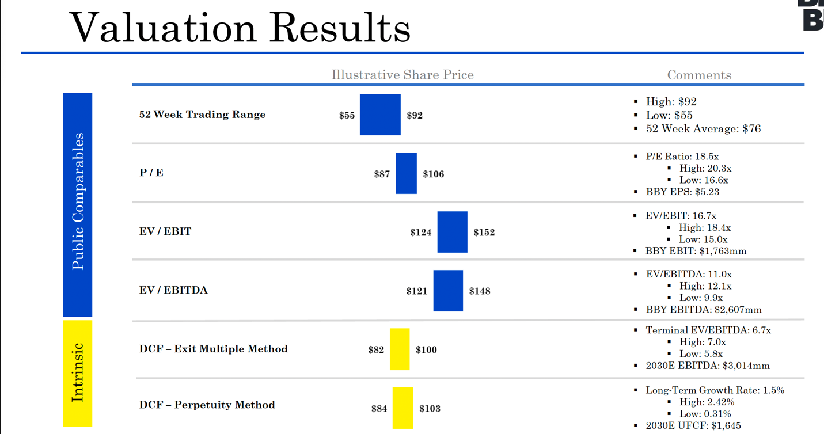
Computing
I model the AI PC wave as a temporary uplift to PC market growth between FY’26–FY’29 driven by higher ASPs (not units) and Best Buy’s outsized capture of incremental “upgrade wallet” dollars via attach, services, and memberships. Pre-2017 wallet share is not representative due to the Renew Blue transition and lack of major cycles between 2017 and COVID, so I use the COVID pull-forward as the key datapoint and estimate Best Buy captured ~72.5% of PC market growth above the “structural” level; I treat this as Best Buy’s share of upgrade dollars under its current model.

I assume an AI PC ASP premium of ~10% (Gartner/Canalys), persisting through 2027, and AI PC penetration rising from ~15% in 2024 to ~94% in 2029 and 100% in 2030, modeled linearly from 2025 (~31%) to 2029. “Structural” PC sales are the average of non-upgrade years (2017–2019, 2023–2024). With flat shipments since 2018 and ~1.4% ASP CAGR, I grow this structural base by the ASP trend. I apply the 10% AI premium and penetration ramp to this base to get incremental “upgrade” dollars, apply Best Buy’s structural share (~39.5%) to structural sales, and its 72.5% wallet share to the incremental AI uplift. Wallet share is raised 10% in the bull case and cut 20% in the bear case.

Marketplace
Best Buy’s current online business is skewed to higher-ticket, less commoditized, often exclusive SKUs; marketplace extends reach into lower-ticket and more commoditized SKUs. Using third-party data that ~32% of online electronics buyers consider budget/non-branded options, I apply (1 – 32%) to U.S. electronics e-commerce GMV (~$196 billion) to estimate the “higher-ticket” pool and infer Best Buy has ~10% share of that segment. Its overall online share of total U.S. electronics e-commerce is ~6.8%; I assume marketplace enables this to converge toward ~10% over five years from FY’26, similar to the 5-year online ramp during Renew Blue (2012–2017). I grow the U.S. electronics e-commerce TAM at 4.4% annually and apply a 9.7% marketplace take rate, based on a blend of Amazon CE take rates (8% below $100, ~15% above $100, weighted by Best Buy’s $136 average ticket) and Newegg (~8%). I flex the take rate ±3 percentage points for bull/bear. This is conservative, as it does not fully capture incremental assortment from OEMs listing more SKUs online with minimal incremental cost.
Incremental Ad Dollars from Marketplace
Incremental ad revenue from marketplace is modeled as GMV monetization. I benchmark GMV-to-ad ratios at Amazon (~7.5%), Walmart (~4.7%), and Etsy (~6.3%) and use the average as my base monetization rate. Incremental third-party GMV is total marketplace GMV less Best Buy’s own online revenue; only this third-party GMV is monetized via retail media. For margins, I use Amazon ad margins (~70%), Walmart retail media margins (~70–90%; I use 80%), and mid-sized networks (~60–70%; I use the upper end), implying high-60s to low-70s % incremental margins on ad revenue.
Best Buy’s online average ticket is ~$136 vs. an estimated ~$82 for broader electronics e-commerce (Statista for electronics/computing/gaming/peripherals), implying a ~66% higher ticket. I assume Best Buy can charge a 66% pricing premium vs. generic e-commerce ad inventory. Smartphones are excluded given ~90% of sales go through carriers/OEMs and are a negligible part of Best Buy’s mix. I flex both the GMV monetization rate (±2 pts) and the pricing premium (±10%) in bull/bear cases.
Consumer Electronics & Entertainment
I decompose growth into three components:
- Secular growth,
- Retail channel share erosion, and
- Cyclical effects from major product/content releases.
E-commerce upside is captured separately in the marketplace model, so these segments are driven by retail channel performance.
Consumer Electronics
I assume no major structural catalysts over the next five years: smartphones are a smaller driver for Best Buy and no step-change innovation is expected in TVs/accessories. Third-party estimates indicate retail channel share for electronics declines ~5.3% annually from 2024–2027, while underlying secular demand falls ~1% per year over 2018–2025. Combined, this supports a –6.3% CAGR for Best Buy’s retail consumer electronics channel over the forecast.
Entertainment (Gaming)
I estimate gaming’s secular CAGR at ~2.5% over 2018–2025. I layer in GTA VI and PS6 (2027–2028) as major cyclical catalysts. The PS5 cycle is COVID-distorted, so I use the 2013 GTA V/PS4 cycle, when industry growth was ~7 pts above the prior five-year run-rate in 2013–2014, as a proxy for the uplift. I also apply a ~4.1% annual decline in retail channel share for 2024–2027 to capture continued mix shift away from physical retail.
Appliances
Appliances remain a secular growth category where omnichannel retailers have structural advantages. Consumers tend to purchase high-ticket appliances in-store to inspect products and receive expert guidance, and players like Best Buy, Walmart, and Home Depot integrate online research, in-store consultation, installation, warranties, and service, making them more competitive than online-only platforms. I assume growth normalizes from COVID-elevated levels but remains above 2019 initially and converges linearly to the long-term U.S. appliances growth rate of 3.8% over the forecast, with no share erosion and no major catalysts.
Services
Services are modeled as an attach to merchandise and expressed as a % of non-ad, non-marketplace revenue. I increase the mix by 0.4 pts next year, then reduce the annual increment by roughly two-thirds each year thereafter, consistent with recent post-COVID normalization.
Margins
COGS as a % of revenue (largely variable) is taken from sell-side; I align with consensus that tariffs are a minor direct hit vs. demand elasticity risk in a downturn.
For SG&A, I regress SG&A (ex-D&A) on revenue to split fixed and variable components to capture the fullest extent of my out-of-consensus revenue view given the company’s high operating leverage. The regression intercept divided by store count yields fixed cost per store, which has stabilized at ~$4.4–4.6 million in FY’23–FY’25; I use $4.5 million and reduce it ~1% annually for efficiency gains. The slope gives the variable component as a % of sales; I roll this forward, excluding 2021 and 2023 as COVID-distorted, with back-test error of –3% to +3%. Given observed increases in variable SG&A share, I add 0.2 pts per year to the variable % over the five-year forecast. Total fixed SG&A is fixed cost per store times a declining store count; the remainder is variable. The tax rate follows consensus sell-side estimates.
Capex & Depreciation
Capex is split into e-commerce, supply chain, and store investments to reflect the shifting asset base. D&A as a % of PP&E has risen as software/intangible-like investments increase, but software and some store capex are capitalized in fixtures, and the company does not disclose D&A by asset class.
To approximate useful lives and depreciation:
- I aggregate cumulative capex by bucket back to FY’16 and calibrate useful lives to match reported D&A: e-commerce/software 4.5 years, supply chain 7.5 years, store 6.5 years.
- Using these lives (rounded up), I compute rolling cumulative capex per bucket to approximate the depreciable base and derive annual depreciation.
- For forward capex:
o E-commerce: 3.3–3.8% of online sales, with online at a normalized 31% of total revenue.
o Store: per-store capex of $0.15 million (down from ~$0.2 million post-COVID).
o Supply chain: 0.1% of merchandising revenue (mid-point of the 0.06–0.15% historical range).
Amortization
Amortization declined from $86 million in FY’23 to $21 million in FY’25; I treat it as de minimis and carry forward at zero.
Working Capital, Debt & Deferred Revenue
AR, AP, and inventory days have been stable for five years; I carry their mid-point levels forward to compute working capital. Debt has seen minimal net paydown over seven years and is 100% long-term; I treat it as effectively permanent and hold it flat. Deferred revenue is modeled at ~3.6% of sales (normalized post-COVID) and held constant as a % of revenue.
WACC
Calculated to be 9.4% using market data, in-line with sell-side reports.
Terminal Value
I use both terminal EV/EBITDA and perpetual growth. The exit multiple is 6.7x EV/EBITDA, derived by backing out the market-implied terminal value from current EV minus the PV of consensus FCFs (discounted at my WACC) and expressing this rolled-forward value as a multiple of exit-year EBITDA. For the perpetual growth method, I use a 1.5% rate consistent with a mature, low-growth retailer. Terminal assumptions are anchored to consensus-implied valuation and do not assume a differentiated long-term secular view.
Appendix A:
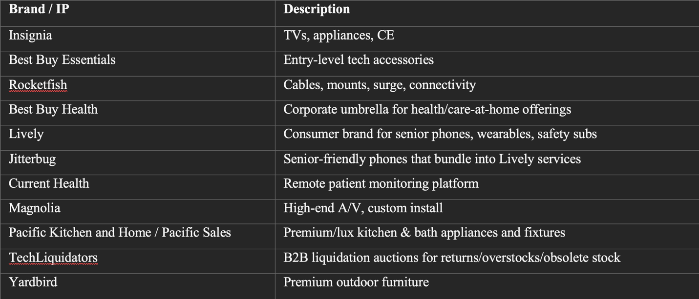
Appendix B:
Calculated as BBY’s share of total US e-commerce sales / consumer electronics share of US e-commerce sales
Appendix C:
History
Best Buy was founded in 1966 as a retailer specializing in high fidelity radios, before expanding to VCR sales in 1983, and going public in 1985. The company was able to compete on both costs and customer experience by pioneering a low-cost, high-volume consumer electronics superstore business model. Stock was placed on the salesfloor rather than in a stock room, and stores had large demonstration areas with broad product assortments with non-commissioned salespeople, contrary its peers, which created a low-pressure selling environment. Best Buy quickly obtained market share from large, well-established competitors like Circuit City and Highland Superstores. Annual sales grew from roughly $10 million in 1983 to $1 billion in 1992, the company was added to the S&P500 in 1999, and eclipsed Circuit City in both sales & earnings by 2000.
Pre-2012: Big Box Growth & Category Tailwinds
The 2000s saw the company expand its number of stores aggressively both domestically & internationally, whilst secular tailwinds as demand for all categories of digital products consistently drove double digit y/y comparable sales growth, and its customer-centric, multi-category pureplay strategy allowed it to dominate the growing market for retail consumer electronics [2000 - 2009 10-k MD&A]. Revenues increased from $15 billion in 2000 to almost $50 billion by 2009 (a roughly 15% CAGR). During this time, management talked about e-commerce as an additional channel to drive traffic to stores—NOT a separate strategic engine [2003 10-k, page "growth in the online channel"].
Between 2007 and 2013, however, revenues fell from X in 2007 to Y in 2012 and operating margins fell from close to 6%, to 1.5% due to declining consumer electronic product life cycles & ASPs, intensifying competition from e-commerce sites, and increasing consumer price sensitivity post-GFC. Most detrimentally, however, customers would inspect products in-store to later buy them on Amazon at a reduced price (dubbed “showrooming”). Between early 2007 and late 2012, BBY’s stock price fell by over 75%.
Post-2012 Turnaround: Renew Blue & True Omnichannel
The precipitous decline in revenue & operating margin during the late 2000s/early 2010s prompted the 5-year Renew Blue initiative under CEO Hubert Joly (who’d joined the company in 2012), in which it pivoted to a much leaner & omnichannel model. First, it shut down underperforming locations in the US, while entirely exiting Europe in 2013 and China in 2014 where it was ceding market share, and materially reducing costs by cutting headcount, and driving supply chain efficiencies [2014 10-k MD&A]
The company also abated market share loss to Amazon by:
- Aggressively price-matching to alleviate showrooming
- Competing with Prime by introducing “ship-from-store” and same-day in-store pickup for online orders at 1,400 locations, turning stores into “mini-fulfillment centers” covering 70% of Americans within a 15-minute radius
- Expanding Geek Squad & other high-margin, value-added services from computers to every other product category (e.g. smartphone tutorials, car GPS-installations, & health-tech setup for hospitals)
- Worked closely with key vendors such as Samsung and Microsoft to massively scale the “store-within-a-store” model inside locations, turning large portions of the salesfloor into branded experiences with dedicated fixtures, staff, and curated assortments. While BBY had experimented with shop-in-shop formats before (e.g., Apple, Magnolia), it was relegated to a limited number of brands. This maximized the customer experience and helped stabilize comps & margins
[OM change & revenue chart]
Appendix D:
Supply Chain Overview
OEMs (which are predominantly in East Asia) handle product shipments to Best Buy’s west coast consolidation centers. From there, products are sent to regional distribution centers (RDCs AKA the hubs, such as those in Long Beach & Seattle), where large shipments are broken down to individual items, and picked on an ad-hoc basis for either store replenishment or DTC for online orders through a Metro E-commerce Center (MEC, or rather, through a store for in-store or curbside pickups). In 2024, the company increased its investments in the supply chain to increase , having opened a new distribution center in Lancaster, Texas to service the growing Dallas market, and implemented autonomous guided vehicles in its New York facility.
[sources: https://www.investopedia.com/articles/personal-finance/072315/why-best-buy-failed-china.asp#:~:text=3%20The%20move%20proved%20to%20be%20far,in%20its%20local%20partner,%20Five%20Star%20Appliance, https://www.theguardian.com/business/2013/aug/09/tesco-withdraws-brand-china-joint-venture#:~:text=An%20online%20business-to-business,service%20wholesale%20business%20would%20continue.&text=The%20American%20electronic%20giant%20opened,failed%20and%20quit%20in%20Europe, https://www-statista-com.proxy.library.vanderbilt.edu/statistics/249602/square-footage-of-best-buy-retail-stores-in-the-us, https://www.tjwaldorf.com/renew-blue-best-buys-turnaround/#:~:text=The%20stopwatch%20on%20Joly%27s%20charter%20to%20turnaround,engage%20and%20inspire%20transformational%20leaders%20and%20employees, https://www.businessinsider.com/best-buy-same-day-delivery-expands-2017-8#:~:text=Follow%20Dennis%20Green,will%20expand%20to%2040%20cities, https://corporate.bestbuy.com/2016/best-buy-is-testing-same-day-delivery/#:~:text=By%20John%20Vomhof%20Jr.,Philadelphia%2C%20Seattle%20and%20Washington%2C%20D.C, https://www.startribune.com/best-buy-stakes-big-share-of-its-future-on-geek-squad/164067446, https://www.seattletimes.com/business/best-buy-bets-big-on-lsquostore-within-a-storersquo-concept, https://www.gurufocus.com/news/3140647/best-buy-bby-shares-surge-amid-trade-concerns-and-strong-sales-outlook?mobile=true, IBIS world, https://www-statista-com.proxy.library.vanderbilt.edu/statistics/1124191/online-revenue-share-total-revenue-best-buy, https://www.statista.com/statistics/274255/market-share-of-the-leading-retailers-in-us-e-commerce/#:~:text=Table_title:%20Market%20share%20of%20leading%20retail%20e-commerce,Share%20of%20retail%20e-commerce%20sales:%201.4%25%20%7C, https://www.mordorintelligence.com/industry-reports/united-states-ecommerce-market#:~:text=By%20device%20type%2C%20smartphones%20commanded,Short%20term%20(≤%202%20years, https://en.wikipedia.org/wiki/Best_Buy, https://historydraft.com/story/best-buy/best-buy-formed-redline-entertainment/841/21136, https://www.latimes.com/business/la-xpm-2011-oct-04-la-fi-ct-rhapsody-napster-20111004-story.html, https://en.wikipedia.org/wiki/Napster, 2000 - 2009 10-k, https://companiesmarketcap.com/best-buy/operating-margin, https://inspireip.com/why-circuit-city-closed, https://www.forbes.com/forbes/2004/0112/138.html, https://www.cepro.com/news/10-failed-electronic-retailers/226/#:~:text=Nowadays%2C%20Best%20Buy%20sits%20as,of%20comfort%20in%20that%20consistency, 2003 - 2012 10-K, https://www.aabri.com/manuscripts/131663.pdf, https://www.bastiansolutions.com/assets/1/6/whitepaper_modernizing_best_buys_supply_chain.pdf?srsltid=AfmBOorlfnYo9HOlbzB1A4A_qZz2xclUkapxUBoewblk14we8o7GDyy0, partners.bestbuy.com/-/supplier-direct-fulfillment-sdf, https://www.retaildive.com/news/best-buy-distribution-centers-ship-from-store-sales/701697, https://www.forbes.com/sites/markfaithfull/2025/05/29/tariffs-hit-best-buy-revenues-as-retailer-reduces-chinese-imports, https://www.m19.com/blog/net-profit-margin-for-amazon-sellers#:~:text=Electronics%20and%20Home%20&%20Kitchen%20typically,who%20position%20their%20products%20effectively, https://www.onrampfunds.com/resources/10-profit-margin-benchmarks-for-ecommerce-2025#:~:text=Amazon%20ads%20can%20consume%2020-33%25%20of%20gross%20sales%2C%20while%20Shopify%20sellers%20typically%20spend%2015-25%25]

